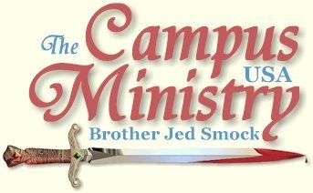
BROJED.org
brojed@aol.com
Cell: 573-999-0347
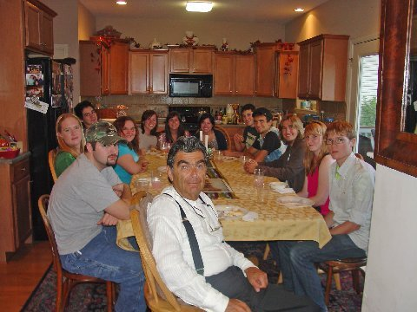
Our Fall Open/House Cook-out for the Students...Over 35 attended, mostly unbelievers...AJ, on the right, is an atheist who provoked a lot of discussion. See details below:

Colorado College, August 31, 2009
A tent was set up on the college green and the school was serving free food to the students. About 20 folks from Victory World Outreach joined me. I preached from the public sidewalk since this is a private college. One student came up and said he appreciated me speaking to the students. Evidently he had heard me in years past. He said, “You bring diversity to this campus.” This young man’s point was that even though Colorado College celebrates diversity, it lacks diversity in thought, which is typical of America’s colleges and universities where liberalism, socialism, secularism, pluralism, feminism, skepticism and multiculturalism prevails with little tolerance for those who disagree.
Gradually, students came over to listen and ask questions. Generally the students were more polite than students at state universities. Many of them had intelligent questions. I noticed the young man who commended me for bringing diversity to the campus was nodding his head in agreement when I taught on the free market. But he was one of the few.
Since I was wearing my warning sign to various sinners which includes socialist and radical feminists, these two issues were frequently addressed. One young man dominated the questions for a couple of hours. Finally, about 2:30 I asked several of the saints from VWO to share their testimonies. The students did listen. By 3 PM there were just a few students remaining so I decided to call it a day and drive on up to Boulder.
As we walked off campus one middle aged gentleman from the church who was excited about the ministry said that it was not what he expected. He anticipated that I would merely be preaching. He enjoyed the teaching, dialogue and interaction. Actually, more fruit may come from the Christians from the church who listened all afternoon to me expounding on various theological, social and political issues than from the unbelieving students as Colorado College.
Victory World Outreach is one of the most supportive churches on my itinerary when it comes to people joining me on campus. I held a tent meeting on their church grounds on Friday and Saturday night and spoke in their building on Sunday morning and Sunday night. Friday night, I had joined them in their weekly outreach to the downtown night clubs. Forty-five people from the church went out into the streets on Friday night. This was an impressive turn out.

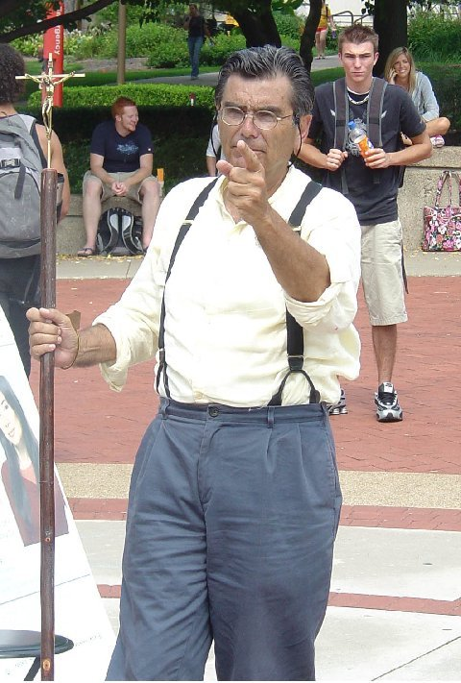

University of Colorado, September 1, 2009
Immediately, I drew a crowd of close to 100. A female freshman whom I commended for her modest ladylike dress and demeanor said she was not a Christian and never attended church. Later she moved to stand beside me for some time and at one point asked to look up something in my Bible. Evidently, she could not find what she was looking for. After a while I asked for my Bible back. She threw it at me. I explained to the crowd, “Her action illustrates that her case is not against me; but it is against God’s Word, the Bible. And so it is with the rest of you. God’s Word is convicting you of your sins; it is pricking your conscience. Down deep you know what I say is true; but you refuse to acknowledge that you are wicked sinners deserving of Hell.” No one refuted my statement.
Towards the end of the day she returned, by this time there were only several people listening. I asked if she had come back to apologize, which I really did not expect. This time she grabbed for the crucifix what she attended to do with it I know not; but it was evident her intentions were not good.
One fellow who challenged me wore a t-shirt representing some Christian organization. If I recall correctly, it was Young Life. He did not like my message even though he had only been listening a few minutes. The problem was that he was judging my message and methods by the negative response of the students, which is typical of Christians on campus. They believe if people respond negatively than the ministry cannot be of God. I asked the boy if he had read the book of Acts. He answered, “I am working on it.”
This also is typical of professing campus Christians. Few of them have read the NT. Their methods of evangelism are not Biblically based.
There were two professing atheists among those listening. I asked the Young Lifer type, “Why don’t you preach to the atheists? They are headed for Hell. Or maybe you don’t believe that?”
He answered, “I can’t say that they are headed for Hell. I am not to judge.”
I replied, “I guess you don’t believe the Bible. Or should I say you don’t know the Bible?”
The male atheist said, “I must come to the preacher’s defense. Christianity does teach that I am headed for Hell. I would rather that a Christian be honest with me instead of some liberal Christian hem hauling around and not give me a direct answer concerning my destiny.”
This Christian fellow had brought up to me the example of Jesus’ witness to the woman at the well as the example on how evangelism ought to be done. He was the second person today to bring up Jesus’ witness to this woman. Last week at KU a Christian told me that I needed to follow this example. Over the years, many Christian students have referred to this witness of Jesus as the example to follow. Evidently teachers of friendship evangelism often use this case from John 4 to illustrate effective witnessing.
Thomas Nelson published WHAT DOES THE BIBLE SAY ABOUT…, in this book there is a topic on witnessing which says, “Many people associate witnessing with street evangelism. But street preachers can sometimes alienate people, although the boldness of their faith is acknowledged by all.”
The editors’ prototype for witnessing is also Jesus’ ministry to the woman at the well. What the editors don’t seem to appreciate is that Jesus alienated most people as did his disciples.
Those who teach Jesus’ approach with this woman usually do not acknowledge that Jesus was abrupt with this woman, “Give me to drink,” he said. Then Jesus’ spoke mysteriously of “living water.” Next, he was somewhat deceptive with her telling her to call for her husband all the while knowing she had no husband. Subsequently, he put his finger on her sin, informing her that he knew that she had had five husbands and the man she was living with was not her husband. After that, he said, “You don’t even know what you worship.” He informed her that God must be “worshipped in spirit and truth.” Finally, he informed her that he was the Messiah.
What really impressed the woman is that Jesus told her what she was doing wrong. She then went into Sychar and told the men, “Come see this man, which told me all things that ever I did; is not this the Christ?” Her testimony sparked a city wide revival. “And many of the Samaritans of that city believed on him for the saying of the woman, which testified, He told me all that ever I did (John 4:39).”
The Christian college students do not witness after this manner. They will rarely address the issue of specific sins in their personal evangelism. Jesus actually used the tactics of confrontational evangelism with this woman, not friendship evangelism.
Finally, the Young Lifer had the audacity to rebuke me for looking down on his youth. I responded, “You are not Timothy, Timothy was a young pastor who had sincerely followed the faith of his mother and grandmother.”
He replied, “I am studying to be a pastor.”
I responded, “You have a long way to go.”
This young lifer was not only taking a verse out of context; but he was misapplying it to himself for the whole verse says “Let no man look down on thy youth; but be thou an example of the believers, in word, in conduct , in charity, in spirit, in faith, in purity.” (1 Tim 4:12) He had informed me earlier that he was a sinner, and that there are none who are pure.
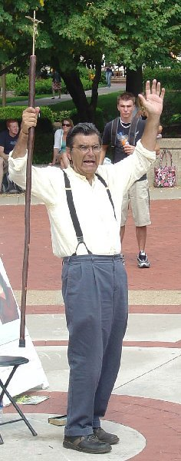

“A GREAT WORK”
Colorado State University, September 2, 2009
There was a fair on the mall where the different campus organizations had set up tents and tables. A rock group was playing. I arrived several minutes late and consequently missed the bulk of the noon break. A few students stopped; but except for one Christian girl, Allison, they did not stay long. Allison is a freshman who is frustrated at the immorality on campus and the socialist views which prevail in the classroom. She is already planning on transferring to a Christian college. Except for going to class for an hour, Allison stayed around most of the afternoon. At one point she spoke boldly for the Lord.
There was quite a large passing of students at the 1 PM break; but again only a few stopped and they did not stay long. I had a lot of competition with all the activity on the mall.
At the 2 PM break close to 100 stopped. I was wearing my “You Deserve Hell” t-shirt which provoked a lot of questions and comments. Although today’s meeting got off to a slow start it turned out to be an outstanding day. By the last hour from 4 to 5 PM, the students were crowded around me very anxious to get answers to their questions. Although they did not speak out during my preaching, three Christians commended me at the end of the day. “You are doing a great work,” one said. Another wanted to help me carry my stuff back to the car. He said that he had had a profitable conversation with an unbeliever while I was expounding the Word of God.
In the evening Duncan C. wrote on my facebook wall, “God bless you. I saw you today on the CSU campus. At first I didn't know what you were about, so I listened for awhile. I found that everything you were saying was truth, and I admire your boldness. I am praying for you and your ministry. Thanks for being my facebook friend!”
CSU has been one of the better campuses over the decades where I sensed that there was often deep conviction of sin. For someone wanting to establish a ministry I think this would be a good campus to build a Christian movement. My prayer is that among the many campus preachers whom God has raised that someone will be successful in getting a breakthrough and be able to establish a successful campus church which will develop into a strong Christian witness on major campuses across America.
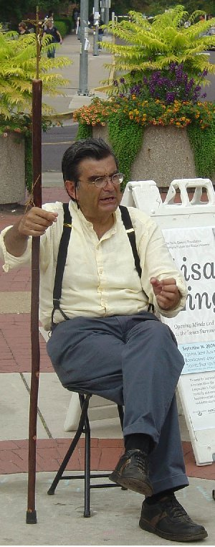

THE CREED
University of Colorado, Sept 3, 2009
Amy, a modestly dressed senior, had been listening an hour, when I asked her if she was a Christian. She affirmed that she was. I asked her to give her testimony. With her meek and quiet spirit, she was difficult to hear; but her excellent demeanor was a good testimony to her fellow students. Later she thanked me for coming to the campus.
On the wall of the Memorial Union outside of which I am preaching I can read the Colorado Creed, “I will act with Honor, Integrity and Accountability in all my interactions with students, faculty, staff and neighbors, Respect the rights of others and accept their differences, Contribute to the greater good of the community. I will strive to uphold these principles with all aspects of my college experience and beyond.”
This creed has commendable aspects but it is thoroughly humanistic. I doubt if most students put it into practice. How can they without the Spirit of the Lord? Of course there is no mention of service to God in the Colorado Creed. Repeatedly, I quoted from the Westminister Shorter Catechism, “Q. 1. What is the chief end of man? A. Man’s chief end is to glorify God, and to enjoy him forever.”
I taught the students the knowledge of God must be the starting point of their education. But, alas, they start with the big bang.
Consequently, two lesbians and two homos kissed passionately in front of me to the cheers of most in the crowd. For rejecting the Creator, “God gave them up unto vile affections.” (Rom 1:25-26)

CAMPUS MINISTER STANDS WITH ME
University of Colorado, September 4, 2009
I started at 9:45 AM since this is a holiday weekend; I did not think the students would be hanging around much in the afternoon. A crowd of 25-35 quickly stopped.
One of the campus ministers, Bobby Pruett, of Christian Challenge, who has been ministering for 25 years at CU, warmly greeted me in front of the students. He boldly commended me before the students and defended the gospel. He stayed around and was still witnessing on the side lines to several students when I left a 2 PM.
I have had fellowship with Brother Pruett on past visits to Boulder. Interestedly, one of the kissing lesbians from yesterday rather warmly greeted me or so it seemed. I invited her to come back later; but I did not see her.
Two students complimented me for provoking a lot of thought on campus.
I drove to Colby, KS for the night.
WHY NOT CONDEMN MURDER, RAPE AND STEALING?
Truman State University, September 8, 2009
I started preaching at the noon break with the help of my crucifix staff and my “You Deserve Hell” t-shirt. It was not a large break. I wondered if a lot of students had not yet returned after the holiday weekend. About 10 students stopped, but within fifteen minutes everyone left.
I returned to the car to get my sandwich board sign which lists damnable sins. A fraternity was set up behind me protesting domestic violence. They were having students put dye upon their hand and put their hand print upon a hanging sheet which read, “These hands will not hurt anyone.”
The next break was not until about 1:15. I said, “These frat boys will not use their hands to slap you girls, but watch out they will try to poke you with their penises and they will use their hands to feel you up. They should be campaigning for the boys to keep their hands to themselves and their penises in their pants.”
I exhorted the passing by students to make sure that they were not doing any of the sins listed on the sign.
This time I did get students to stop and stay. For the rest of the afternoon an attentive and civil audience averaged around 25 students, and another 20 or so frat boys in the background. A few times students asked, “Why do you have all these sins listed which deal with party life like drinking and sex and feminism and socialism; but have not listed rape, murder, or stealing?”
I explained, “No one is going to defend rape, murder, or stealing. Virtually everyone admits that those things are wrong. But not only are many students getting drunk, stoned and having sex, but they refuse to admit that these things are wrong. They even think that socialism and feminism is good. The sign is designed to capture people’s attention and provoke discussion and debate.”
The frat boys were not getting much attention for their cause; except that they were giving away food. None of the students are going to defend domestic violence against which they have been thoroughly indoctrinated. But if they should promote soberness and abstinence many students would stop and engage them as they do me. So it is with the Christians on campus: they will condemn what everyone else condemns; but they will not condemn what most students are practicing and justifying.
It was a delightful day; by 3 PM most of the students were sitting on the ground and several of them had brought over folding chairs which were stacked by the library. One of the frat boys even brought me a glass of water. It seems that when one can get the students to sit down, it has a calming influence. This is one reason that I carry a folding chair. I am less threatening to them when I am sitting than when I am standing. After 4 PM most of the audience was professing Christians. I exhorted them to be bold in the witness and live holy lives and to bear their cross.
I concluded with prayer at 4:45; but even after my prayer students lingered asking questions. I did not stay long because I had almost a two hour drive back to Columbia where Cindy was expecting me for dinner. Several asked me when I would be returning. Earlier in the day I heard students saying, “Brother Jed is back.”
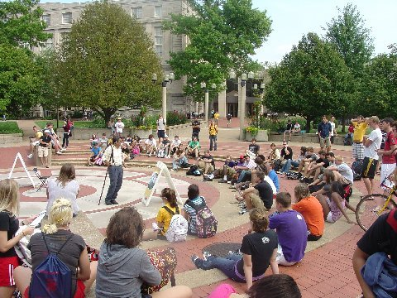

WHO HAS PUT THE GUN TO MAN’S HEAD?
University of Missouri, September 9, 2009
Sister Cindy, Martha and Priscilla and two home school boys, twin brothers Nolan and Morgan, joined me on campus. Cindy was in top form and at times the crowd must have been 250-300 people. The girls and their friends held signs while Cindy and I preached. It was the first time the school boys had been on campus to hear us preach. Our girls passed through the crowd a number of times passing out invitations to our annual fall cookout and open house on Friday. Both Cindy and I spent a considerable amount of time telling our life stories. Although a significant number have probably heard these stories numerous times, they never seem to tire of hearing them again. Of course, a good story is worthy of hearing many times over. For instance, I have read and told the story of the conversion of Saul of Tarsus countless times; and it still excites and inspires me. And I usually get new insights into the grace of God though Paul’s glorious conversion each time I contemplate his Damascus road experience.
Cindy had to leave campus with the youth at 3 PM. I carried on for two more hours. There was lots of good Q and A during this time. I reconciled the doctrine of eternal Hell with a loving God. One student suggested that God has put a gun to people’s head and said repent or else. But I explained that the fact is the man has put a gun to his own head and is determined to blow himself into Hell and God is doing all he can to get him to put down his gun. The unsaved man is like the drowning swimmer resisting the life guard who is trying to save him.
I explained the necessity of the atonement. I enlighten the students on the morality of capitalism over socialism. I elucidated on the superiority of Christianity over all other religions. Basically, I demonstrated the folly of unbelief in the God of the Bible. Unfortunately, students have a lot of misconceptions concerning the true God, which too often have been propagated by the church. They have been taught of a God who has absolute knowledge of the future and can do absolutely anything, yet as the same time has given men a free will. Such a God is a logical impossibility.
Cindy and I agreed it was another glorious and wonderful day on campus.
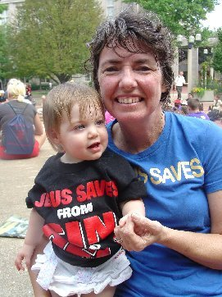
Iris's First Day on Campus: Note Bible T-shirt that once belonged to Priscilla
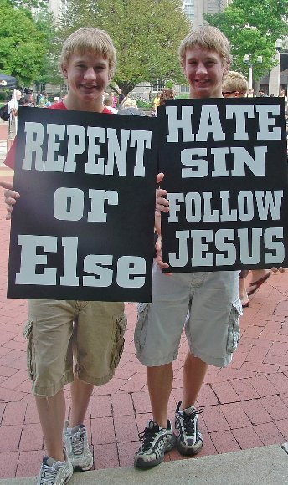
Nolan and Morgan, homeschool juniors join us on campus.

THE HACKY SACK MAN AND THE ANTLERS
University of Missouri, September 10, 2009
At noon there was a middle-aged male playing hacky sack by himself to music in speakers’ circle. This was supposed to be a performance of a dance. I decided not to interrupt since I do tend to dominate the circle when I am in town. He danced for over an hour. Now and then I moved through the area passing out invitations to our Friday open house cookout.
Meanwhile, The Antlers, an organized group of rowdy Mizzou basketball fans who heckle and harass opposing players in a vulgar and lewd manner, were recruiting in the circle. To the Antlers nothing is sacred and there are no boundaries. Basically, they are nihilists; but I doubt if any of them have any idea what the term means. After the hacky sack man stopped, I took my usual place at the center of the circle. The Antlers kept shouting inane remarks to passing students; so I decided to wait on the Lord before I started preaching and to let my crucifix staff be my witness. A number of students began gathering in the circle; but I still refrained from preaching. Finally, at around 1:45 one of the students in the circle called me over to answer a question. Soon several others moved towards us who also had questions. Still the Antlers were shouting what they considered clever nihilist one liners.
I had captured the attention of many and for the rest of the afternoon I occupied center stage in the Circle with a crowd of up to 50 or so. The Antlers gave up their recruiting around 3 PM; and I continued preaching until 5 PM.
Tanya, a pretty female who claims to be a virgin and former Christian turned atheist, and who listened and interacted with Cindy and me most of the day yesterday, was in the audience again today. Another attractive female, who confessed to not being a virgin, whom I suggested might want to apply for work at Hooters, listened and interacted most of the day. She justified herself by being in a long time committed relationship.
Late in the afternoon a Christian girl came to the defense of the gospel. For about the last 30 minutes she had a group of students around her.
Considering all the distractions within speakers’ circle today, it turned out to be a good day of evangelism.
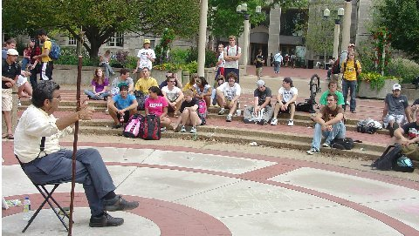
Speaker's Circle, University of Missouri

OPEN HOUSE AT THE SMOCKS
University of Missouri, September 11, 2009
Some brothers from a Calvinist Church in Kirksville, MO (home of Truman State University) were preaching in speakers’ circle when I arrived at noon. They posted scriptural messages on standing folding boards and had a banner along a wall. Two young preachers and one middle-age preacher held forth until almost 2 PM. This group makes an appearance on campus a few times a year. Today the preachers received more attention from the students than I have noticed in years past. One of the young preachers [I think his name was John] was the best preacher that I have heard from this organization. He projected his voice better than the others. They also interacted with the students better than I have noticed in years past and usually had the attention of about 25. This group is non-confrontational and none of the exchanges were heated. One who questioned them was Tanya, who has been interacting with us all week. Interestedly, last year I received communication from one in their group saying that I would not need to preach at Truman State since they have that campus covered. But evidently, they do not think that I have my flagship campus, the UM, covered.
I moved through the crowd a few times passing out invitations to our open house. Meanwhile, Jack introduced himself to me and thanked me for influencing him to turn to God last year. He told me that he had been speaking prophetically against the New World Order last year and the FBI investigated him and his parents required him to go into psychiatric care. He is not in school now. He is visiting his sister who is a student at Mizzou. He lives in Colorado; but he does not have a job. He plans on snowmobiling this winter. He did speak of getting involved in YWAM. I encouraged this. He needs stability and guidance. When the Calvinist crew finished, Jack went into the circle and gave the students a brief exhortation.
Afterwards, I took over and tried to liven things up. Shortly afterwards the Calvinists left. I have the impression that they don’t care for my preaching. I built up the crowd somewhat. Cindy arrived about 2:45 and I turned the meeting over to her. Her preaching further increased the size of the crowd. Cindy left at 3:30 to make the final preparations for the open house. I wrapped things up at 4:30.
We had our best turn out ever for the open house. Usually, we have around 20 people, typically half are Christians. This time we had thirty who signed the guest register and we think at least five more who did not sign in. Most were unbelievers, a few professed to be Christians but after talking to them I had my doubts. Six of the Christians who attended by special invitation were graduates of homeschooling who are now in college or college age. Cindy has influenced these youth through the youth activities and Bible studies she has led for our homeschool support group. For most of the evening the dining room, the kitchen and the porch tables were filled with students.
A.J. was a young man with a Catholic background who now professes atheism. He engaged Cindy and me on campus in the afternoon. Atheists are always good to keep the discussion lively since they tend to be zealous in promoting their anti-God views. I spent much of my time talking with him at two different table discussions. One of the homeschool graduates, Brittney, was active in witnessing to the students. One of them asked her what she thought of our methods of evangelism. Brittney knew virtually nothing about our confrontational style; but she answered wisely saying, “If the Smocks passed out a tract saying God loves you and with an invitation to their church, do you think that you would be here tonight?” The students got her point.
Two boys, Kevin and John, were repeats from past open houses. Kevin was once a heckler but after attending our open houses he stopped heckling. He says he now speaks well of us to his fellow students. Hilary, who professes to follow Christ and one who dresses lady-like, was also a repeat from past open houses.
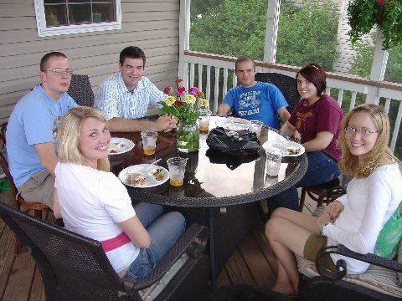
Kevin, on the left, and John on the right are both repeat attendees at our open house. Pray for them;they are both unbelievers. Brittney, on the right is a homeschool graduate who did a great job of witnessing.

Three girls, Laura, Diana and Jessica, arrived about 7:30; but they stayed about an hour after everyone else left, except for the homeschool graduates. Cindy and I had good conversation with the three girls. Each of them had been churched. Jessica said her parents never went to church; but she started going on her own as a child. She said she hoped to talk with us more in the future. Laura professed to have been born again; but she was now questioning her faith.
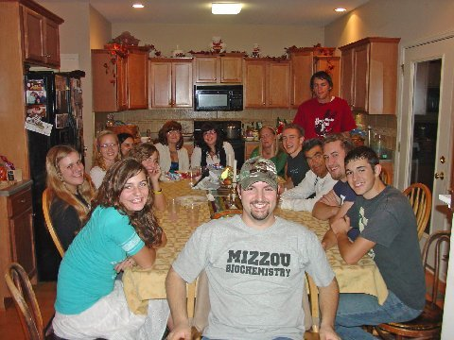
Students came and went throughout the evening. We had three different tables for seating! The biochemistry student (front) is Andrew Nelson a homeschool graduate and pre-med student at Mizzou.
Emma and Nick were journalism students. Cindy gave an interview to Emma and both of them were taking notes all evening. There were about twice as many girls as boys who attended. Cindy gave her testimony to a group of mostly Catholic girls at the dining room table.
Everyone seemed to enjoy the evening and the discussions. Everyone stayed for at least an hour and most for longer. Cindy, the girls and I were very pleased with the response. We passed out 300 invitations on campus, which means that over 10% responded and came to the meeting. I was disappointed that Tanya, who said she was coming, was a no show. But I know how the devil will do what he can to keep people away.

You Can Help
Dear Saints,
Our cash flow is a little low right now so if you have been thinking of donating but putting it off, now is the time. Bro. Jed just left for a six week trip which will incur a lot of travel expenses. You may donate to CMUSA by sending a check to our home office, 2402 Longview Dr. Columbia, MO 65203 or by using PayPal through our website, brojed.org

Attention prayer warriors: you are vital, keep up the good work and increase!

Thank you much,
Sister Cindy

